Ideation Phase
Define the Problem Statements

Date | 15 February 2026
Team ID | LTVIP2026TMIDS80981
Project Name | Orderonthego : your on-demand food ordering solution
Maximum Marks | 2 Marks

Problem Statement -1:
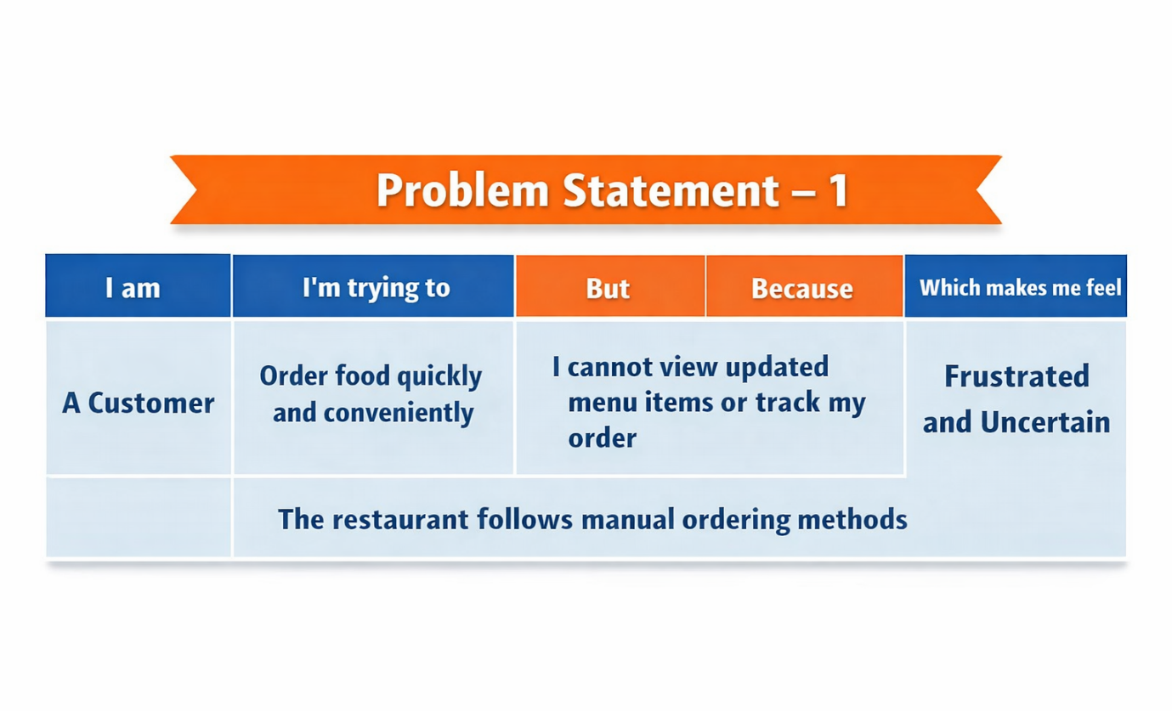

Problem Statement -2: 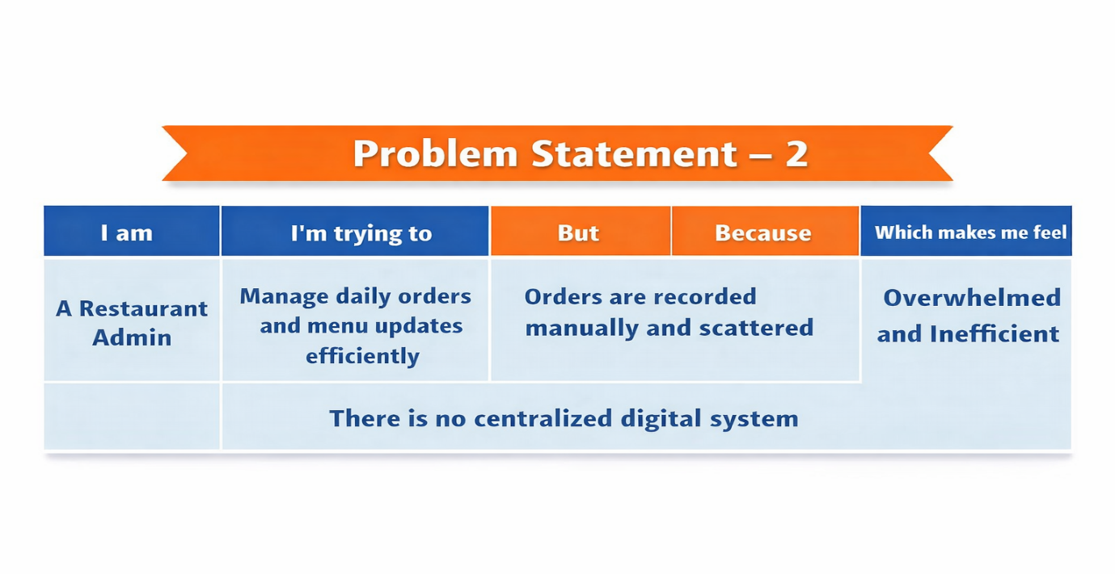
Problem Statement (PS) | I am | I’m trying to | But | Because | Which makes me feel
PS-1 | A Customer | Order food quickly and conveniently | I cannot view updated menu items or track my order | The restaurant follows manual ordering methods | Frustrated and uncertain
PS-2 | A Restaurant Admin | Manage daily orders and menu updates efficiently | Orders are recorded manually and scattered | There is no centralized digital system | Overwhelmed and inefficient

